Thermodynamics with Complications

A pocket dictionary for students and unstudents

*With bonus illustrations about Susskind’s Cat.*These notes are meant as a refresher on classical thermodynamics, but we also re-interpret the usual variables in terms of computational complexity and uncomplexity in the context of ideas from Susskind and others.

We explore two “dictionaries”: one that identifies complexity with interior volume (the standard Susskind picture), and another that treats uncomplexity as the volume-like variable, highlighting its role as a resource similar to free energy.   
We see how familiar thermodynamic tools — Maxwell relations, heat capacities, and equations of state — look when translated into these languages.

All work done is basically renaming of variables in classical thermo plus spelling out the interpretations. We also include an exposition of a “graded second law” in spirit of Munson et al, 2025.

A Note on Coarse Complexity

Exact circuit complexity is *path dependent*: the number of gates needed to reach a state depends on its precise history.  
To treat complexity like entropy, we must coarse-grain: define a smoothed complexity $C_{\text{coarse}}$ ​ that ignores microscopic fluctuations.

This is analogous to thermodynamics itself: entropy is only well-defined after averaging over microstates.  
All formulas below apply to *coarse complexity*.

# Two Dictionaries

## Standard (Susskind’s) Dictionary: Complexity = Volume

| Thermodynamics: | Complexity Analogue: |
| --- | --- |
| Entropy $S$ | Complexity $C_{\text{coarse}}$ |
| Temperature $T$ | Complexity temperature $T_{C}$ ​ (scrambling rate) |
| Volume $V$ | Interior volume $∼C$ |
| Pressure $P$ | Complexity pressure $P_{C}$ ​ (resistance/cost to changing volume) |
| Free energy $F$ | Uncomplexity $U=C_{max}-C$ |
| Heat $δQ$ | Uncontrolled scrambling |
| Work $δW$ | Useful computation |

## Alternative Dictionary: Uncomplexity = Volume

| Thermodynamics: | Complexity Analogue: |
| --- | --- |
| Entropy $S$ | Complexity $C_{\text{coarse}}$ |
| Free energy $F$ | Uncomplexity $U$ |
| Volume $V$ | $$∼U$$ |
| Pressure $P$ | $P_{C}$- conjugate variable to uncomplexity (still resistance/cost to consume resource) |
| Heat $δQ$ | Random complexity growth |
| Work $δW$ | Useful computation |

Both mappings are consistent.

Complexity = Volume is cleanest in black hole geometry.

Uncomplexity = Volume highlights the *resource character* of uncomplexity as “free energy for computation.”

Carathéodory / integrating factor view:

In ordinary thermo, $δQ$ has an integrating factor $1/T$ so that $δQ/T = dS$. Here, we’re ***defining $δQ_{C}≡T_{C}dC$*** , i.e. the integrating factor is $1/T_{C}$ ​ and the state function is $C$. This encodes the coarse-grained assumption: ***on the equilibrium manifold*** complexity is a state function and $δQ_{C}/T_{C}$ ​ is exact.

“Complexity free energy” $F≡E-T_{C}dC,$ $dF=-CdT_{C}​-P_{C}​dV$.

# First and Second Laws

In terms of complexity:

$$dC= δQ + δW$$

In terms of uncomplexity:

$$dU=-\left(δQ+δW\right)$$

*Heat*: uncontrolled complexity growth.

*Work:* directed, useful computation.

Second law of complexity:

$$δQ≥0 ⟹ \text{complexity tends to increase.}$$

# Maxwell Relations

Start from:

$$dE=T_{C} dC-P_{C} dV$$

Take exterior derivative:

$$0=-dT_{C}∧dC+dP_{C}∧dV$$

This gives:

$${\left(\frac{∂T_{C}}{∂V}\right)}_{C}=-{\left(\frac{∂P_{C}}{∂C}\right)}_{V}$$

Other potentials yield the family:

${\left(∂C/∂V\right)}_{T_{C}}={\left(∂P_{C}/∂T_{C}\right)}_{V}$, ${\left(∂T_{C}/∂P_{C}\right)}_{C}={\left(∂V/∂C\right)}_{P_{C}}$, ${\left(∂C/∂P_{C}\right)}_{T_{C}}=-{\left(∂V/∂T_{C}\right)}_{P_{C}}$

These are consistency conditions: the scrambling rate, volume, complexity, and complexity pressure can’t vary independently.

# Heat Capacities

At fixed volume: $C_{V}=T_{C}{\left(\frac{∂C}{∂T_{C}}\right)}_{V}$, At fixed pressure: $C_{P}=T_{C}{\left(\frac{∂C}{∂T_{C}}\right)}_{P_{C}}$

As in ordinary thermodynamics.

Interpretation**:**  
Heat capacity tells us *how much extra complexity the system absorbs per unit change in scrambling rate*, under different constraints.

$C_{V}$: “rigid” interior geometry (volume locked).

$C_{P}$: “relaxed” geometry (volume free to shift to keep pressure constant).

By the stability relation

$$C_{P}-C_{V}=T_{C}\frac{{\left[{\left(∂P_{C}/∂T_{C}\right)}_{V}\right]}^{2}}{{\left(∂P_{C}/∂V\right)}_{T_{C}}}$$

we know $C_{P}≥C_{V}$ if the system is stable.

So, the system can absorb more complexity growth if the interior is allowed to adjust than if it is frozen.

# Toy Manifolds for two equations of state

We can visualize the state space as a surface in $\left(T_{C},V,P_{C}\right)$.

## Ideal Gas

Equation of state:

$$P_{C}V=κT_{C}, C=α\ln{T_{C}}+β\ln{V}.$$

Isotherms: hyperbolae ($P_{C}∝1/V$).

Heat capacities: $C_{V}=α,C_{P}=α+κβ.$

Mechanically stable: ${\left(∂P_{C}/∂V\right)}_{T_{C}}<0$.

EOS surface:  
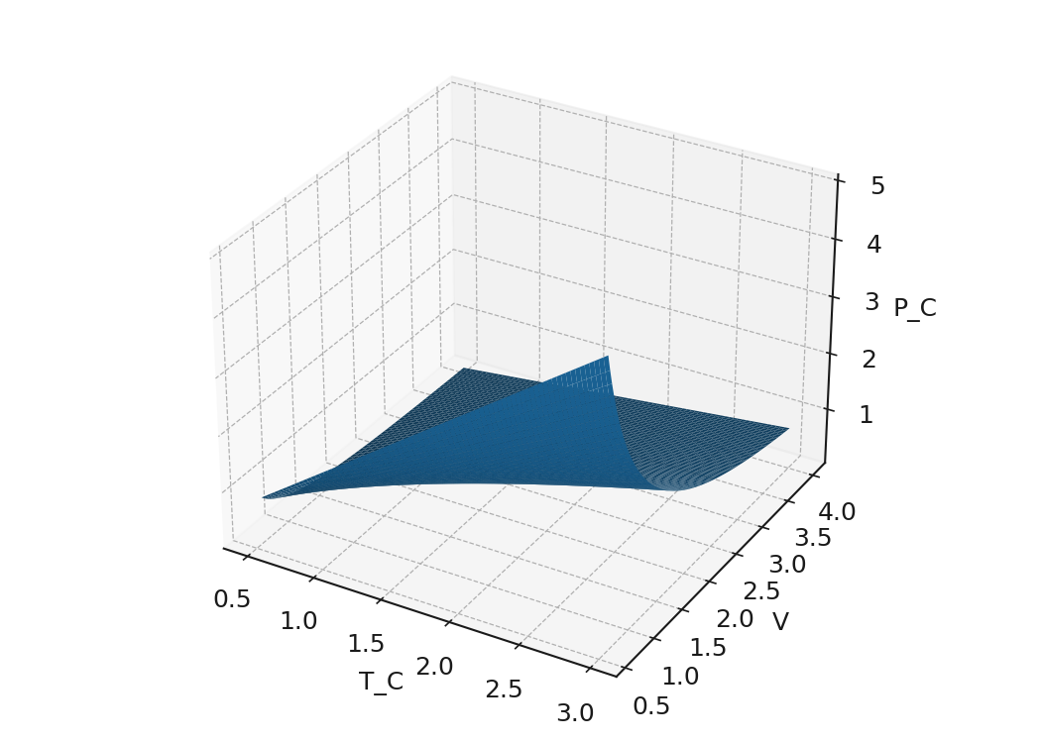

Isotherms:  
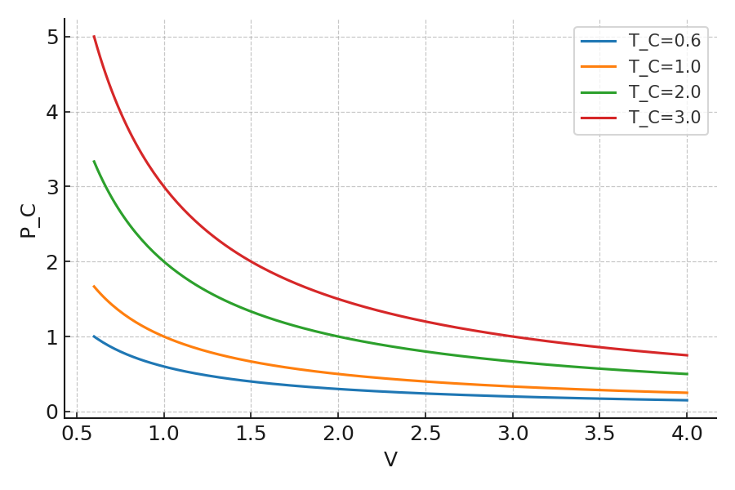

Isocomplexity contours:  
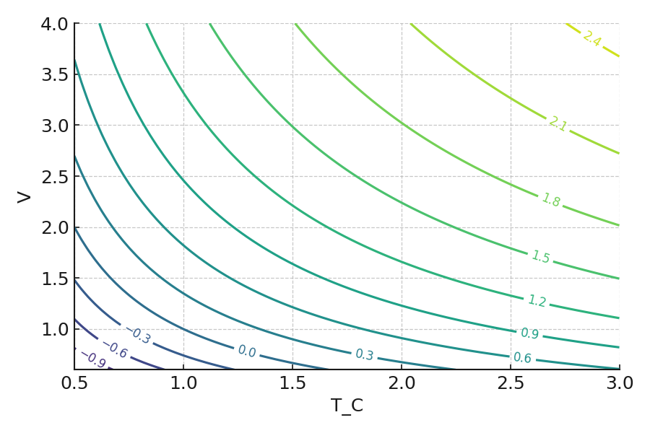

## Fast Scrambler

Equation of state:

$$P_{C}\left(T_{C},V\right)=\frac{A\tanh\left(BT_{C}\right)}{V}$$

At small $T_{C}$ ​: linear in $T_{C}$ ​ (like ideal gas).

At large $T_{C}$ ​: saturates (tanh $→1$).

At small $V$: diverges like $1/V$.

Interpretation:

High $T_{C}$ ​: saturation — complexity growth capped (fast scrambling).

Low $V$: divergence — small interiors resist compression; young black holes are highly sensitive.

Large $V$: pressure falls, mature black hole interior grows smoothly.

EOS surface:  
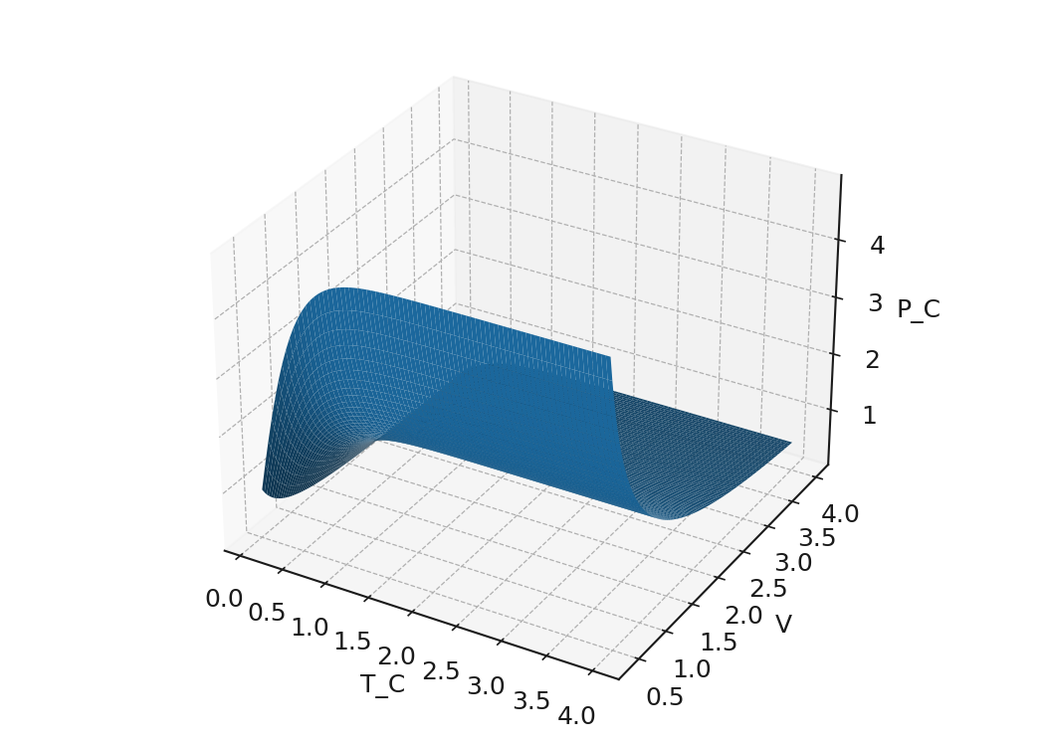

Isotherms (zoomed to highlight divergence and saturation):  
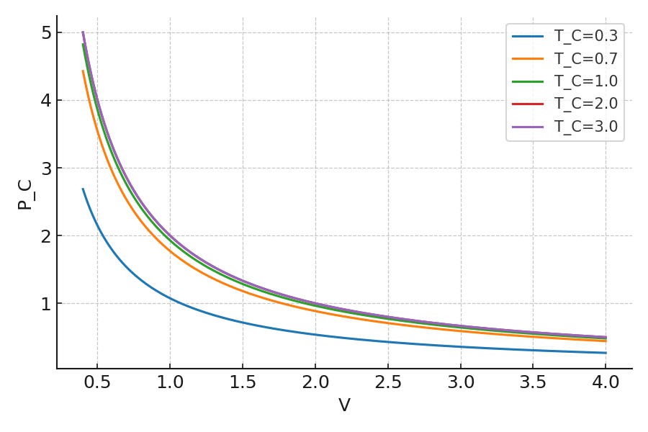

# Black Hole Analogy

*Complexity, Volume:* interior volume growth matches complexity increase.

*Pressure*: conjugate to interior volume, interpreted as “resistance/cost of expansion.”

*Heat:* scrambling, random gate growth.

*Work:* harnessed uncomplexity for useful computation.

*Saturation:* black holes are fast scramblers, complexity growth caps at maximal rate.

*Small volume divergence:* newborn black holes are hypersensitive, interiors hard to “compress.”

Black holes keep growing inside even when equilibrium is reached outside. Their effective complexity pressure is negative (like cosmological constant): the system *wants* to expand volume/complexity. By contrast, an integrable system with constrained state space exploration might have a positive complexity pressure: pushing it into new computational territory is costly. $P_{C}$ ​ measures how costly it is (in terms of “computational energy”) to increase the interior volume (complexity) at fixed coarse complexity.

# Complexity of complexity, but different complexity

It is worth repeating that thermodynamics in its standard form distinguishes two modes of energy transfer:

Work ($W$): ordered transfer of energy, ideally reversible.

Heat ($Q$): disordered transfer of energy, intrinsically associated with entropy growth.

Free Energy $F = E - TS$: the maximum extractable work from a system in equilibrium with a reservoir at $T$. Energy splits into “usable” (free) and “unusable” (heat/entropy) components. The partition is sharp: reversible vs. irreversible. Real processes differ not just in *whether* they are reversible, but in how difficult it is to reverse them.

So, we can consider a ladder of energy modes:

Work $F$ (reversible, efficient).  
Ordered energy transfer; in principle and in practice, fully recoverable.

Polynomial Free Energy $F^{\text{poly}}$.  
Energy stored in a state that is reversible with polynomial overhead. Still feasible in practice, but not “frictionless.”

Exponential Free Energy $F^{\text{exp}}$.  
Energy theoretically recoverable (unitary dynamics ensures reversibility), but only by procedures requiring exponential time or resources. Effectively lost to finite agents.

Heat $TS$**.**  
Energy randomized beyond recovery, even in principle at the coarse-grained level.

The total energy decomposes as

$$E=F + F^{\text{poly}} + F^{\text{exp}} + TS$$

Processes tend to push energy downward along the ladder:

$$F → F^{\text{poly}} → F^{\text{exp}} → TS$$

Munson et al., 2025 introduced the idea of complexity entropy — the amount of work cost that appears when erasure or transformation must be done by a complexity-bounded agent.

E.g. If the agent is limited to polynomial algorithms, then $F^{\text{exp}}$ behaves as if it were already heat. Thermodynamics of agents: what is free energy to a demon is partly entropy to a complexity-bounded observer.

*A Graded Second Law*

For any computational class $D$ (“difficulty”),

$$\frac{d}{dt}F_{}^{D} ≤ 0$$

The amount of energy accessible as work to a complexity-bounded observer cannot increase. There is a family of second laws indexed by computational power.

Black Hole Connections

Hayden–Preskill 2007 showed that in principle, information thrown into an old black hole can be recovered from Hawking radiation after the scrambling time.

Harlow–Hayden 2013 argued that decoding Hawking radiation requires exponential time in the entropy of the hole. That shifts most of the would-be free energy into $F^{\text{exp}}$. It is reversible in principle, but not in practice: information is locked in exponentially hard work.

The flow down the ladder is the physics of scrambling:

directed work (smooth states) → polynomially inaccessible states (scrambled radiation) → exponentially inaccessible states (deep interior correlations) → thermal entropy.

Literature:

Thermodynamics of Information. Juan Parrondo, 2023, [arXiv:2306.12447](https://arxiv.org/abs/2306.12447)

The Second Law of Quantum Complexity. Brown, Susskind, 2017,  [arXiv:1701.01107v2](https://arxiv.org/abs/1701.01107v2)

Complexity-constrained quantum thermodynamics. Munson et al, 2025,  [arXiv:2403.04828v2](https://arxiv.org/abs/2403.04828v2)

The Organization of Intrinsic Computation: Complexity-Entropy Diagrams and the Diversity of Natural Information Processing. Feldman et al., 2008,  [arXiv:0806.4789](https://arxiv.org/abs/0806.4789)

Revisiting thermodynamics in computation and information theory. Chattopadhyay, Paul, 2024, [arXiv:2102.09981v2](https://arxiv.org/abs/2102.09981v2)

Appendix A: The Carnot Cycle dictionary

High-complexity reservoir (scrambled system): provides “randomness” / complexity growth.

Low-complexity reservoir (clean qubits): provides uncomplexity, like free energy.

Engine: a quantum computer that uses the uncomplexity.

Work $W$: useful, directed computation (solving a problem, extracting information).

Heat $Q$: uncontrolled growth of complexity (scrambling).

A Carnot engine takes in heat $Q_{hot}$ from a hot reservoir at temperature $T_{hot}$, releases heat $Q_{cold}$ to a cold reservoir at temperature $T_{cold}$, and produces net work $W=Q_{hot}-Q_{hot}$. The cycle is reversible, and efficiency is $η=1-T_{cold}/T_{hot}$.

1. Isothermal complexity increase (at “high $T$”):
   * The system couples to a high-complexity reservoir (maximally mixed/scrambled environment).
   * Complexity $C$ increases, volume grows.
   * Some of this growth is controlled, yielding useful computation.
   * Analogous to absorbing $Q_{hot}$

​
2. Adiabatic complexity compression:
   * System is isolated, but you reorganize gates without contacting reservoirs.
   * No “heat” (random complexity) flows, only volume rearrangement.
   * Analogous to entropy-conserving expansion/compression.
3. Isothermal complexity decrease (at “low $T$”):
   * The system couples to a low-complexity ancilla (a fresh clean qubit register).
   * You dump excess complexity into it, thereby refreshing uncomplexity.
   * Analogous to releasing $Q_{cold}$
4. Adiabatic reset:
   * Isolated reconfiguration back to the initial circuit structure.

After this closed loop, you’ve consumed uncomplexity and extracted useful work or computation.

Computation powered by uncomplexity is only possible when there is a gradient in scrambling environments.

Appendix C: Bonus illustrations about Susskind’s Cat

***Susskind’s Cat spends precious uncomplexity to play:***



***Susskind’s Cat looks small outside… but its interior volume grows forever:***

